Quakers Hill Public School

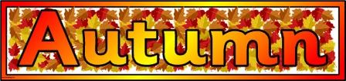
Little Library:
AutumnTheme
Get ready for big school at Quakers Hill Public School. Each term at QHPS we will be holding two special sessions for all pre-schoolers who will be attending school in 2024. These sessions are for both parents and children.
Where: In the library
When: 9.30am Wednesday 1 March 2023
Cost: NIL
Who: All pre-school age children and their parents/carers

Wear your favourite autumn clothes and accessories.
Come and meet some teachers, sing a song, read a book, and have lots of fun!
Take home some great craft and make new friends. Looking forward to seeing you there!
Please look out for other Little Library dates in 2023.

