Quakers Hill Public School
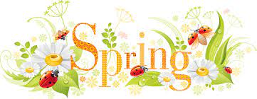
Little Library: Spring
Get ready for big school at Quakers Hill Public School. Each term QHPS holds two special sessions for all pre-schoolers who will be attending school in 2023. These sessions are for both parents and children.
Where: In the library
When: 9.30am-10.30am, Friday 16 September 2022
Cost: NIL
Who: All pre-school age children and their parents/carers

Wear spring colours
Come and meet some teachers, sing a song, read a book, make some Spring craft, and have lots of fun!
Looking forward to seeing you there!
Please look out for other Little Library and Kindergarten 2023 Transition dates in 2022.
